**Tut-7, CLL113**

Q1.Writa a C program to fit a linear regression line through Least Square Method that fits the following data points.

(A)

(1)Use Smmation Method

(2)Use Matrix Method

(3)Find the correlation coefficient in both cases.

(B)Repeat procedure (A) for ***y*** being the dependant variable.

Comment whether the regression lines obtained in both the cases (A) and (B) are same or not.

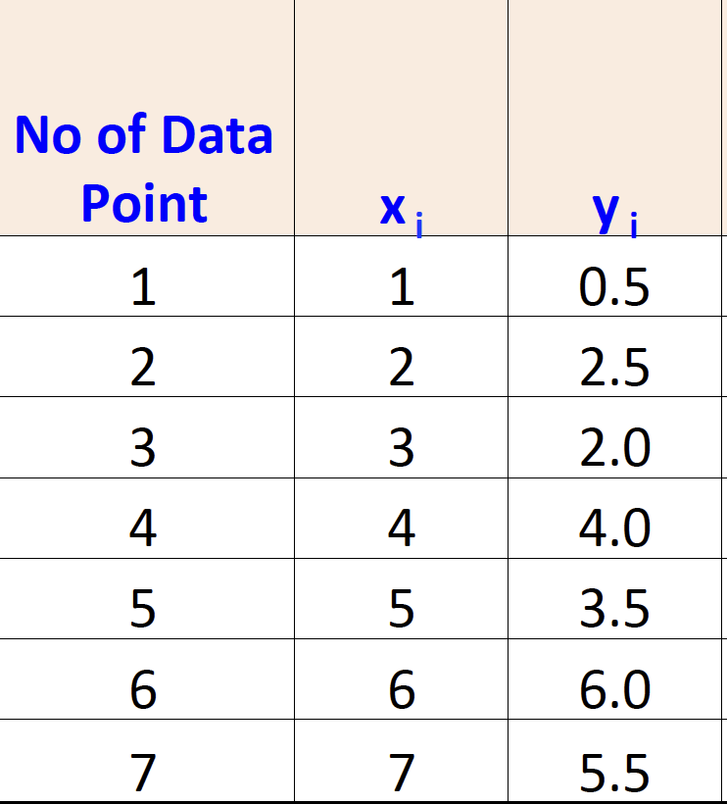

Q2.Writa a C program to fit regression planes through Least Square Method that fit the following data points.

(1)Use Smmation Method

(2)Use Matrix Method

